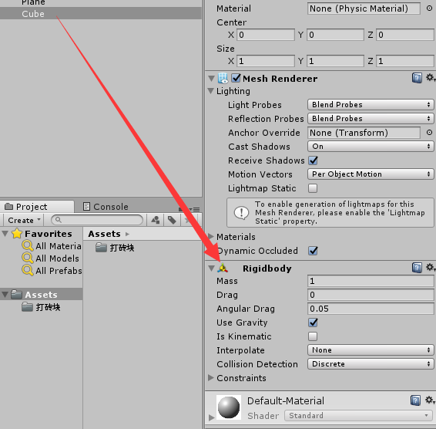

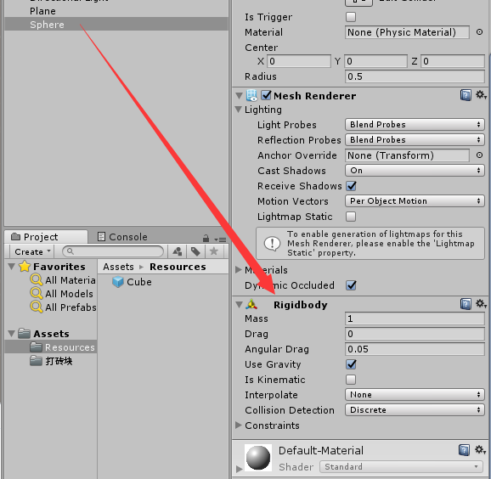

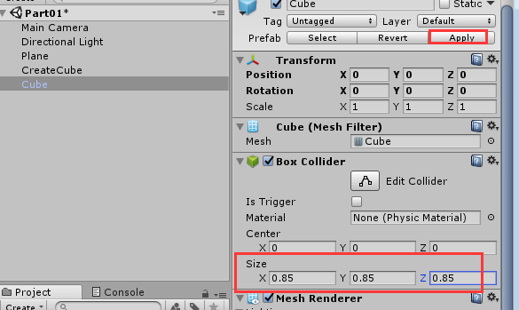

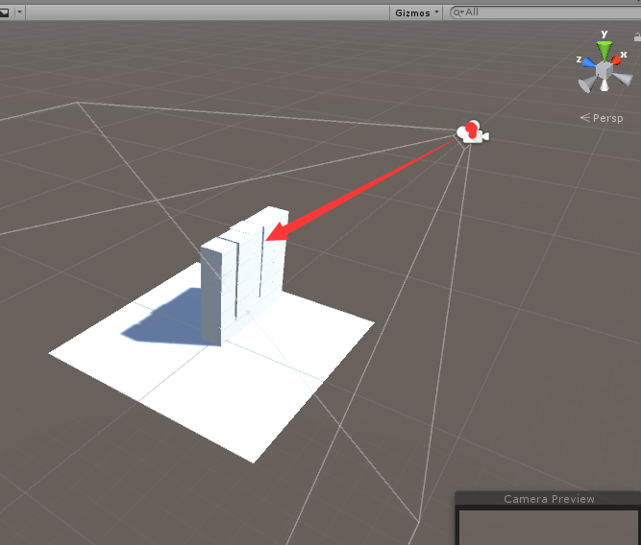

**代码：**

GameObject cube;

void Start()

{

cube = Resources.Load<GameObject>("Cube");

for(int i = 0; i < 5; i++)

{

for (int j = 0; j < 5; j++)

{

GameObject obj = Instantiate(cube, new Vector3(i, j, transform.position.z), Quaternion.identity);

//设置父物体

obj.transform.SetParent(transform);

}

}

}

GameObject sphere;

RaycastHit hit;

void Start()

{

sphere = Resources.Load<GameObject>("Sphere");

}

void Update()

{

if (Input.GetMouseButtonDown(0))

{

Ray ray = Camera.main.ScreenPointToRay(Input.mousePosition);

if(Physics.Raycast(ray,out hit))

{

GameObject bullet = Instantiate(sphere,Camera.main.transform.position, Quaternion.identity);

//求得方向向量

Vector3 dir = hit.point - Camera.main.transform.position;

//normalized:

bullet.GetComponent<Rigidbody>().AddForce(dir.normalized*1000f);

}

}

}

}